Django App for Church. Initial App built from: [Django Web Framework (Python) - Learn web development | MDN (mozilla.org)](https://developer.mozilla.org/en-US/docs/Learn/Server-side/Django)

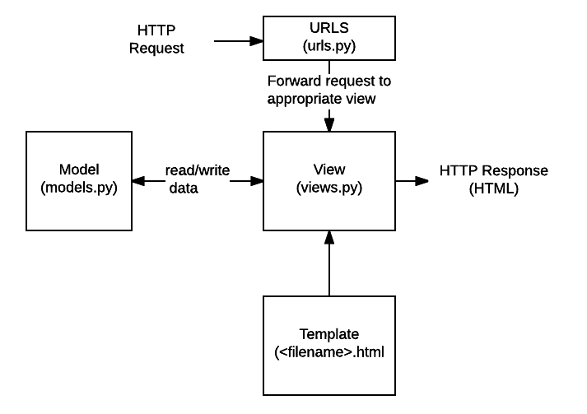

Databases Needed

User: <From Django>

* superuser/manager: treasurer
* alternate_manager
* alternate_manager
* user1: Catherine
* user2: Mary
* user3: Mark <Not required since he is salaried>

Active_Users:

* user [1]
* activation_date
* deactivation_date
* phone_number (if not in User from Django)
* notification_preferences (text, email both)

Period:

* period
* period_no
* calendar_year (Jan-Dec, *yyyy*)
* fiscal_year (Sep-Aug, FY*yy*)
* starting_date
* reporting_date
* submission_date
* pay_date

Payroll_Hours:

* period [*..*]
* active_user
* worked_date
* starting_time
* ending_time
* vacation_hours: True/False
* adjustment_hours: Correction from previous month (positive or negative). Ignores the Starting Time/Ending Time and Vacation Hours if non-zero. Adjustment Hours cannot be non-zero if Vacation Hours is True
* employee_submitted: True/False – Hours submitted by employee

Notification Requests: Want website to automatically deliver email reminders:

* 2 days to period closure
* No hours submitted in a week
* Hours submitted by Users to SuperUser

Future:::

Payroll Summary: Get from Ministry Works

Active User

+user: UserAuth[1]

+start_date:DateField

+end_date:DateField

+phone:Phone (if)

+preferences:Notifications

  + __str__:String

UserAuth

 <See Django>

 + __str__:String

Period

+Calendar Year:

+Period:Number

+StartDate:DateField

+EndDate:DateField

  + __str__:String

Payroll Calendar

PeriodId:[1..*]

UserId

Date

Starting Time

Ending Time

Vacation Hours: True/False

Adjustment Hours: Correction from previous month (positive or negative). Ignores the Starting Time/Ending Time and Vacation Hours if non-zero

Employee Submitted: True/False – Hours submitted by employee

  + __str__:String